Fall 2019

1 a) What is computer organization? Describe the addressing modes use in computer.
1 b) What is micro-operations? Explain different shift micro-operations used in computer with example.
2 a) Preform (4)*(-3) using Booth’s algorithm.
2 b) What is control memory? How micro-programmed control unit works?
3 a) What is control unit? Explain the inputs and outputs of control unit.
3 b) What is memory hierarchy? Describe direct and set-associative mapping.
4 a) Explain different levels of RAID with their advantages and disadvantages.
4 b) How interrupt driven I/O is different from DMA? Describe the working mechanism of DMA.
5 a) Assume that pipeline has K=8 segment and executes n=100 tasks in sequence. Let the time taken to process a sub-operation in each segment in 30 sec. Calculate the speed up ratio in the pipeline.
5 b) Explain the technique of solving hazards on pipelining.
6 a) What is multiprocessor system? Describe the interconnection structures in multiprocessor.
6 b) Describe the hardware and software performance issues of multicore organization.
7. Write shorts notes on any two:
a) Design principles for modern system
b) Arithmetic pipelining

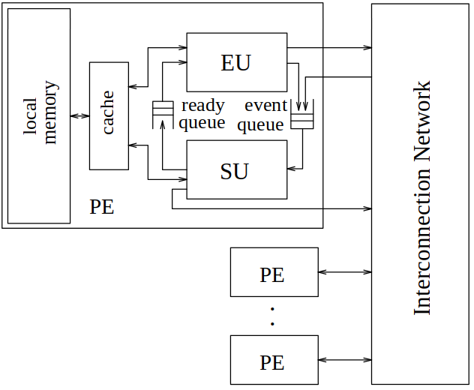Figure: Multi-Threaded Architecture
c) Multi-Threaded Architecture

Multi-threaded architecture (MTA) is a architecture designed for efficient parallel execution of both numerical and non-numerical programs.

Major feature of MTA include the Register-Use Cache for exploiting terminal locality in multiple register set microprocessor more efficiently, support for programs requiring non-determinism and speculation, and local function invocations which can utilize registers for parameter passing.

Spring 2018

1 a) Define computer organization and architecture. Explain the instruction set used in IAS computer.
1 b) What is register organization? Describe data-flow interrupt cycle and execute cycle with diagram.
2 a) Multiply two number (3)×(-2) using Booth’s algorithm.
2 b) Explain in details about hardwired and micro-programmed control unit with their applications.
3 a) What is control unit? Describe the function unit and control of the processor.
3 b) What is cache memory? Explain direct, Associative and set Associative mapping in cache memory.
4 a) Write the difference between RAM and ROM.
4 b) What is I/O module? Explain the major function of an I/O module.
5 a) Assume that pipeline has K=6 segment and executes n=150 tasks in sequence. Let the time taken to process a sub-operation in each segment in 50 sec. Calculate the speed up ratio in the pipeline.
5 b) What is pipeline hazard? Describe branch hazard with different resolution technique.
6 a) What is parallel processing? How can we achieve parallelism in uni-processor system?
6 b) Explain Flynn’s classification. Explain software and hardware solutions for cache coherence.
7. Write shorts notes on:(Any two)
- Arithmetic and logical micro operation
- BCD Arithmetic unit
- Power efficient processors

2018 Fall

1 a) What is addressing mode? Describe different addressing modes used in computer.
1 b) Explain the applications of Logic Micro Operations. Define HDL.
2 a) What is instruction cycle? Explain dataflow fetch and interrupt cycle with diagram.
2 b) Preform (7)₁₀ ×(-3) using Booth’s Algorithm.
3 a) Explain the algorithm for Unsigned Multiplication.
3 b) Explain control unit with controls, inputs and outputs with diagram.
4 a) Differentiate between hardwired and micro-programmed control unit.
4 b) Define RAID. Explain Memory hierarchy. Write the difference between magnetic disk and magnetic tape.
5 a) What is mapping? How set associative mapping is different from associative mapping?
5 b) Why DMA has priority over CPU when both request a memory transfer? A programmed I/O Operation keeps the CPU busy needlessly. Explain.
6 a) What are the conflicts that may arise in instruction pipe-lining?
6 b) What is cache coherence? Explain in details about Flynn’s classification.
7. Write short notes on any two:
- Structure and Functions of computer
- RISC vs. CISC
- Dual Core and Quad core processors

